**Ai assisted coding:**

**Lab exam : 2**

**H.tNo : 2403A51291**

**Batch no : 12**

**Task-1:**

**Question:**

**Prompt:**

**Write a Python function with mypy-friendly type hints that returns the target if found in a list, otherwise raises ValueError("not found"), using TypeVar and include a pytest-style negative test for ids=['a','b'], target='c'.**

**Code:**

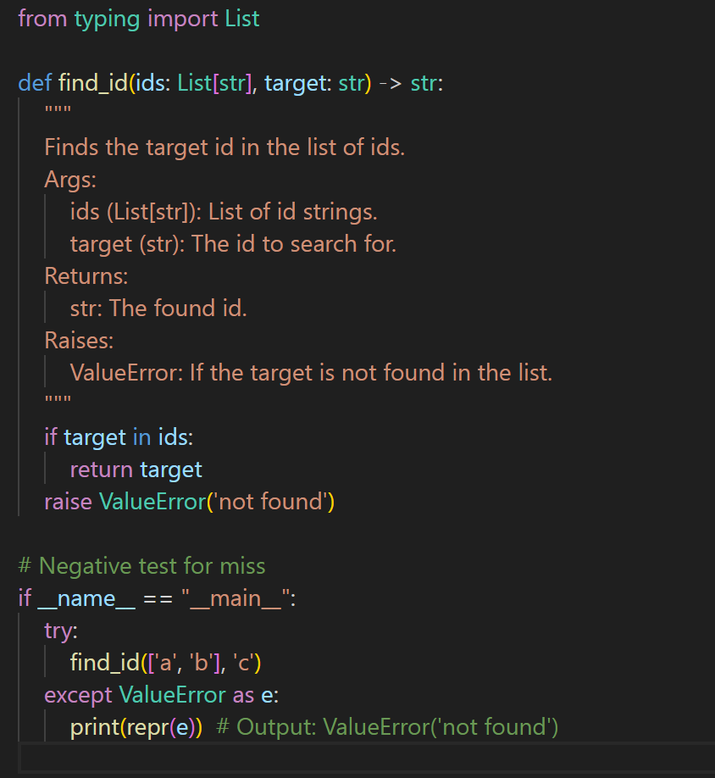

**Output:**



**Task-2:**

**Question:**

**Prompt:write a python function with mypy-friendly type hints that converts a corpus a set and maps a stream to bolleans for membership checks ,provide complexity analysis (0(N+M)) , and include pytest -style tests including the case corpus =[1,2,3,4,5],stream=[2,5,9] -> [True,True,False]**

**Code:**

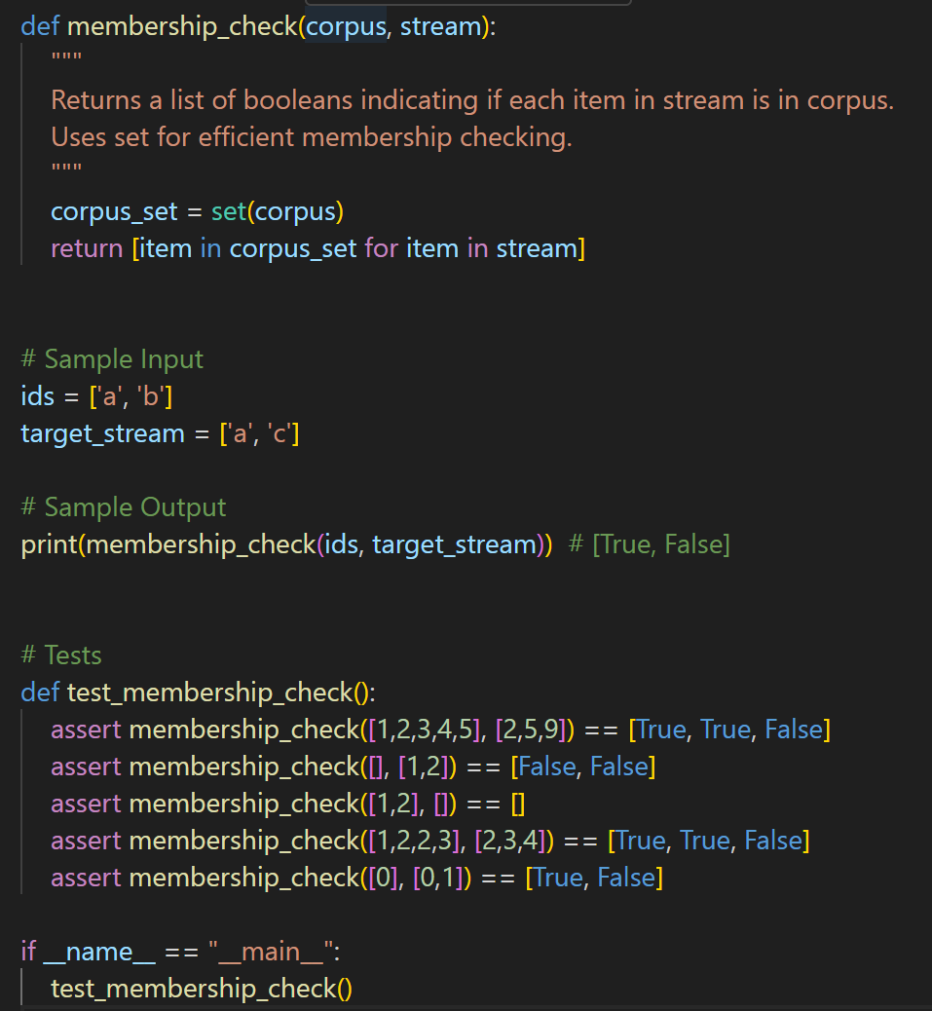

**Output:**

